***States of Matter***

In [physics](http://en.wikipedia.org/wiki/Physics), a state of matter is one of the distinct forms that different [phases](http://en.wikipedia.org/wiki/Phase_%28matter%29) of [matter](http://en.wikipedia.org/wiki/Matter) take on. Four states of matter are observable in everyday life: [solid](http://en.wikipedia.org/wiki/Solid), liquid, [gas](http://en.wikipedia.org/wiki/Gas), and [plasma](http://en.wikipedia.org/wiki/Plasma_%28physics%29).

***Solid, Liquid and Gas***

***Solid:*** In a solid the particles (ions, atoms or molecules) are closely packed together. The [forces between particles](http://en.wikipedia.org/wiki/Bonding_in_solids) are strong so that the particles cannot move freely but can only vibrate. As a result, a solid has a stable, definite shape, and a definite volume. Solids can only change their shape by force, as when broken or cut.

***Liquid:*** A liquid is a nearly incompressible [fluid](http://en.wikipedia.org/wiki/Fluid) that conforms to the shape of its container but retains a (nearly) constant volume independent of pressure. The volume is definite if the [temperature](http://en.wikipedia.org/wiki/Temperature) and [pressure](http://en.wikipedia.org/wiki/Pressure) are constant.

***Gas*:** A gas is a compressible fluid. In a gas, the typical distance between neighboring molecules is much greater than the molecular size. Gas molecules have very weak or no bonds at all. The molecules in "gas" can move freely and fast. Not only will a gas conform to the shape of its container but it will also expand to fill the container.

*The table below is a great guide to the relationship between solids, liquids and gases:*

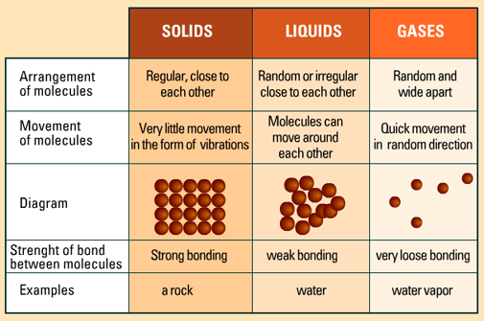

*Any substance may exist as a solid, liquid or gas*

***Heating and Cooling a Solid:***

If a [solid is heated](http://www.gcsescience.com/e10-particles-solid-liquid-gas.htm) enough, [it will melt](http://www.gcsescience.com/e10-particles-solid-liquid-gas.htm) to become a liquid. The [temperature](http://www.gcsescience.com/pen3-heat-temperature.htm) at which it melts is called its [melting point](http://www.gcsescience.com/e10-particles-solid-liquid-gas.htm). If the liquid is then cooled, it will freeze to become a solid again. The temperature at which it freezes is called its freezing point. The melting point and the freezing point is the same for the same substance.

Sometimes a heated solid will turn into a gas without first becoming a liquid. This is called sublimation. Examples of solids that sublime are [iodine](http://www.gcsescience.com/iiodine.htm) and [carbon dioxide](http://www.gcsescience.com/i-carbon-dioxide.htm).

***Heating and Cooling a Liquid:***

If a [liquid is heated](http://www.gcsescience.com/e10-particles-solid-liquid-gas.htm) enough, [it will boil](http://www.gcsescience.com/e10-particles-solid-liquid-gas.htm) to become a gas. The temperature at which it boils is called its [boiling point](http://www.gcsescience.com/e10-particles-solid-liquid-gas.htm). If the gas is then cooled, it will [condense](http://www.gcsescience.com/e7-fractional-distillation.htm) to become a liquid again. A gas will condense at its boiling point.

A liquid can also become a gas by [evaporation](http://www.gcsescience.com/e10-particles-solid-liquid-gas.htm). This happens at a temperature below its boiling point.

***Interconvertion between a Solid, Liquid and Gas:***

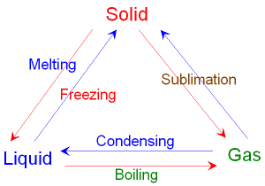

**Fig.1.** Interconvertion from one state to another by heating or cooling

***Plasma:*** Plasma is one of [the four fundamental states of matter](http://en.wikipedia.org/wiki/State_of_matter#The_four_fundamental_states). When a gas is [ionized](http://en.wikipedia.org/wiki/Ionization), plasma forms. Heating a gas may [ionize](http://en.wikipedia.org/wiki/Ionization) its molecules or atoms (reducing or increasing the number of [electrons](http://en.wikipedia.org/wiki/Electrons) in them), thus turning it into plasma, which contains [charged](http://en.wikipedia.org/wiki/Charge_%28physics%29) particles: positive [ions](http://en.wikipedia.org/wiki/Ions) and negative electrons or ions. Like gas, plasma does not have a definite shape or a definite volume unless enclosed in a container.

Normally, the electrons in a solid, liquid, or gaseous sample of matter stay with the same atomic nucleus. Some electrons can move from atom to atom if an electrical [current](http://searchcio-midmarket.techtarget.com/definition/current) flows in a solid or liquid, but the motion occurs as short jumps by individual electrons between adjacent nuclei. In plasma, a significant number of electrons have such high energy levels that no nucleus can hold them.

*Solid is a state of matter in which the particles of a substance are not free to move but have fixed positions about which they can vibrate. In a solid atoms or molecules are attached to one another with strong force of attraction that’s why it has particular volume and shape.*

In general solids can be classified into two categories such as:

(i) Amorphous or Non- crystalline

(ii) Crystalline

***Crystalline solid:*** Crystalline Solid is the solid form of a substance in which the atoms or molecules are arranged in a definite, repeating pattern in three dimensions. Constituent atoms or molecules are arranged in a regular manner and produced by the repetition of pattern unit. It has fixed melting point. The presence of long-range order is thus the defining property of a crystal. *Examples:* Salt and sugar.

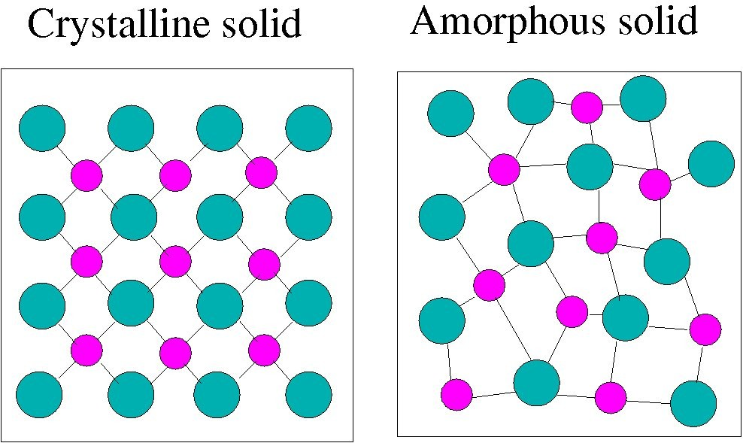***Amorphous or Non-crystalline solid:*** In amorphous or Non-crystalline solid Constituent atoms or molecules do not repeat periodically in three dimensional patterns. It has no fixed melting point. Amorphous solids do exhibit short-range order in their structures. Glass, pitch and many plastics are *examples* of such amorphous solids.

***Differences between Crystalline & Amorphous solids:***

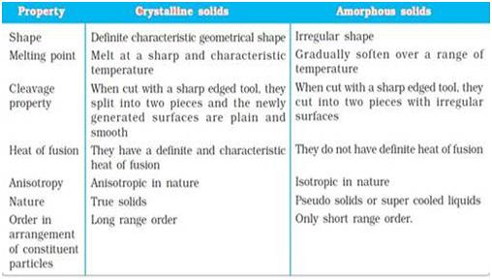

***Types of Crystalline Materials:*** There are two types of crystalline materials

1. Single Crystalline materials
2. Polycrystalline materials

***Single Crystalline materials:*** A single crystal or mono-crystalline solid is a material in which the crystal lattice of the entire sample is continuous and unbroken to the edges of the sample, with no grain boundaries. When periodicity of the pattern stretch out to many cubic cm in volume is called single crystal. In the case of single crystal the periodicities of atoms extend throughout the material, here is no grain boundary. A homogenous solid formed by a repeating, three-dimensional pattern of atoms, ions, or molecules are having fixed distances between constituent parts. The unit cell is of such a pattern. *Example:* Diamond.

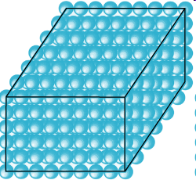

***Polycrystalline materials:*** Polycrystallinematerials are composed of a number of smaller crystals. Most of the crystalline solids are made up of millions of tiny crystals called grains and are called to be polycrystalline.

In polycrystalline crystals the periodicity does not extend throughout the crystal but is interrupted at grain boundaries. Polycrystalline materials are solids that are composed of many crystals of varying size and orientation.

Polycrystalline is the structure of a solid material that, when cooled, forms crystallite grains at different points within it. The areas where these crystallite grains meet are known as grain boundaries. A **grain boundary** is the interface between two [grains](http://en.wikipedia.org/wiki/Crystallite), or crystallites, in a polycrystalline material.

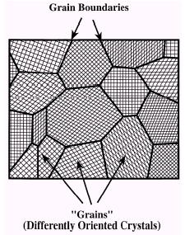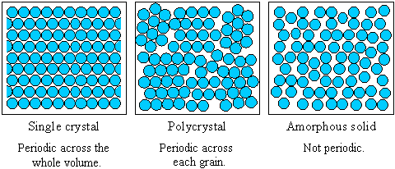

***Some Definitions***

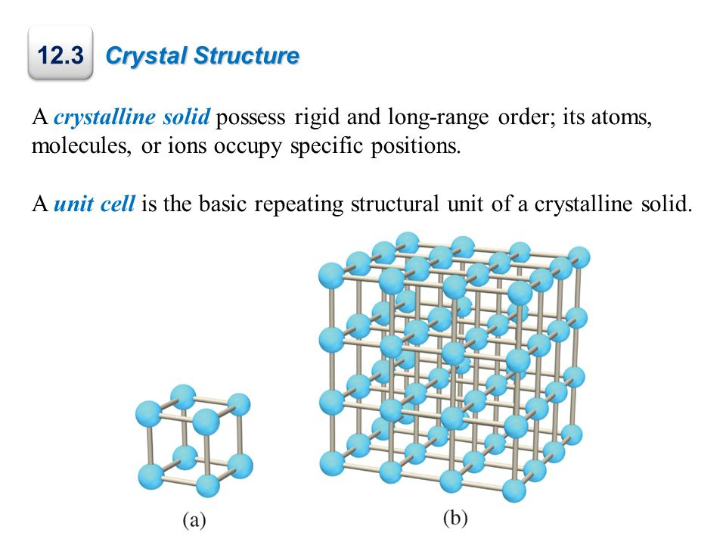***Crystal:*** A crystal is a three dimensional regular and periodic arrangement of atoms. An ideal crystal is formed by the infinite regular repetition of identical structural units in space in the form of parallelepiped shaped. NaCl, ZnS are the examples of crystal.

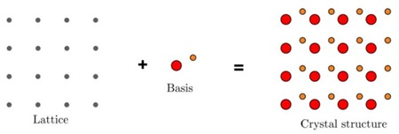***Lattice:*** A lattice is a regular and periodic arrangement of points in space. It may be two or three dimensional. In other words the resulting collection of periodic points in space is called crystal lattice.

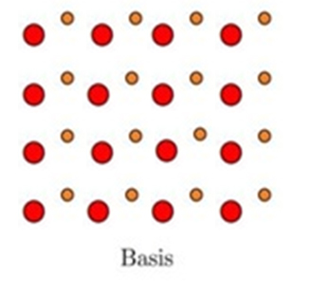***Basis:*** The structure of all crystal is described in terms of a lattice with a group of atoms attached to each lattice point. The number of atoms or molecules present at the lattice is called basis. It is repeated in space to form the crystal structure. A basis is an assembly of atoms identical in composition, arrangement.

***Crystal structure:*** A crystal structure is formed when a basis of atoms is attached identically to every lattice point. The logical relation is,



$Lattice + Basis = Crystal Structure$

***Plane lattice:*** If all the atoms are arranged in a plane, then it would be visible like below picture. In this way in two dimension plane all points will have same atomic surroundings. This arrangement of atoms is called plane lattice.

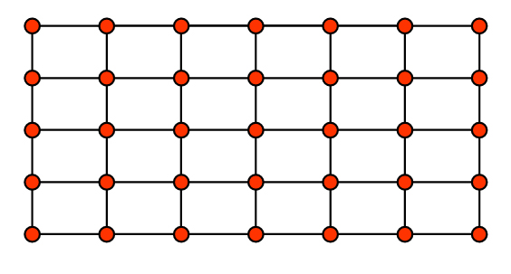

***Space lattice:*** If all the atoms are having similar surroundings in three dimensional spaces like below figure, then such type of atomic arrangement is called space lattice.

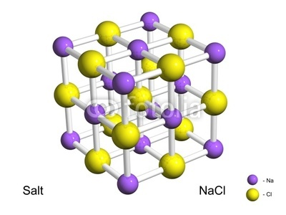

There are two types of lattice

1. Bravais lattice
2. Non-Bravais lattice

***Bravais lattice:*** There are various ways of positioning points (lattice) in space such that all points have same identical surroundings, *i.e.* all points are of same kind and equivalent. These lattices are known as Bravais lattices. Bravais showed that, there exist no more than 14 space lattices in three dimensions. In order to specify the arrangements of points in a space lattice, he introduced 7-system of axes or crystal system.

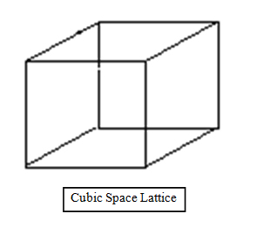

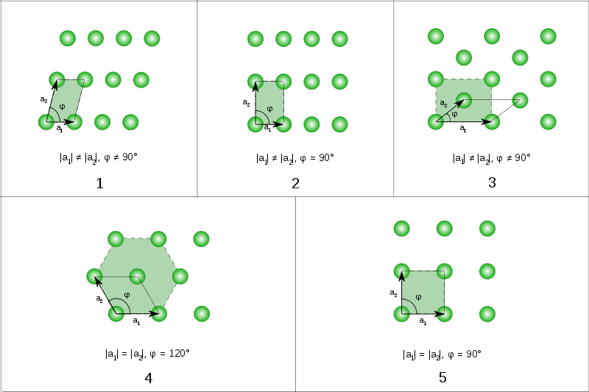

Oblique Lattice

Square Lattice



***Non-Bravais lattice:*** All points are not identical compared to each other known as non-Bravais lattices.